My first step is ____________.

I still have a question

about ________.

I learned _______

when _______.

_____ is important

because _______.

If ________

then _________.

The answer is ________

because _______.

A better strategy would be ________ because _______.

_______ and _______ are similar

(or different) because _______.

This reminds me of _________ because _________.

I agree (or disagree) with ______ because ______.

I solved the problem by ________.

I proved my thinking by ________.

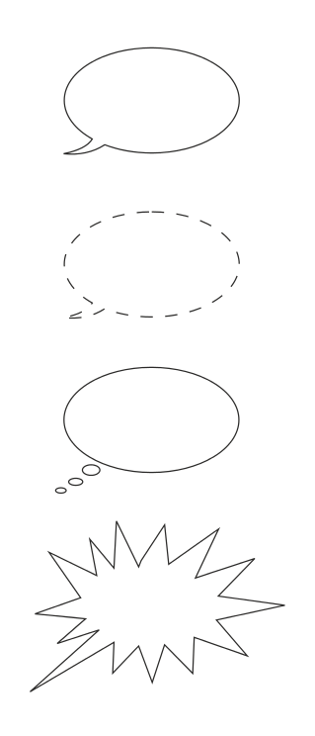The four most common speech balloons, top to bottom: speech, whisper, thought, scream.

I think __________ because

_____________.